SURVAILANCE, GUILT, AND THE COLLECTIVE MEMORY OF FRENCH ALGERIA IN CACHE (2005)

by
NEJRA KRAVIĆ

SUBMITTED TO SCRIPPS COLLEGE IN PARTIAL FULFILMENT OF THE DEGREE OF BACHELOR OF ARTS

PROFESSOR FRIEDLANER
PROFESSOR RACHLIN

DECEMBER 4, 2020
Table of Contents
- Abstract (p.3)
- Introduction (p.4)
- The Plot: Wealth and Complacency (p.4)
- Defining French Algeria (p.5)
- The Paris Massacre of 1961 (p.7)
- Surveillance, Guilt, and Collective Memory (p.9)
- The Aftermath of 9/11, Politics, and Cache (p.14)
- The Gaze, Transnational Cinema (p.16)
- Conclusion (p.18)
- References (p.19)

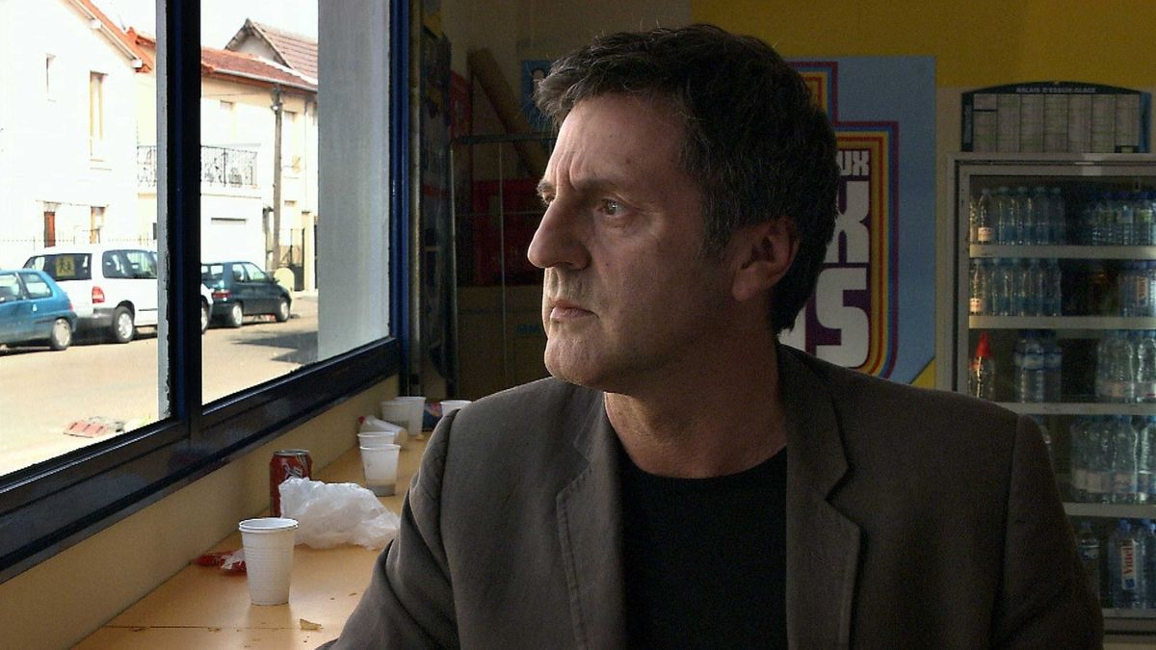
‘‘It is a duty of art to ask questions, not to provide answers. And if you want a clearer answer, I’ll have to pass.’’-Michael Haneke
Abstract: An incredible amount of scholarship has been written about Michael Haneke’s Cache (2005). The film naturally perplexed audiences and critics alike, posing a lot of interesting questions and seemingly choosing to answer none of them. I focus here not so much on the whodunit narrative, that is, granted, very intriguing, but more so on the use of surveillance in the film, and how it informs audiences’ understanding of guilt, French colonialism, and memory. By drawing on a number of film and media theories, I hope to look at how surveillance is used both as a medium and a narrative tool in the film, as well as analyze its role in a much broader cultural context within the post 9/11 period.

Introduction
Michael Haneke’s Cache (2005) shocked audiences when it initially premiered at the Cannes Film Festival. The film has since become notorious for its use of on screen violence, as well as its ambiguous ending that does little to reveal the plot’s main culprit. Set in modern France, the story follows an upper-middle-class Parisian couple that starts receiving a series of mysterious tapes that indicate their family is under surveillance. Baffled at first by the anonymously sent videotapes and graphic drawings, Georges Laurent (Daniel Auteuil), a television host and public figure, recalls childhood memories that seem to be connected to places and events referenced in the tapes. He is led to his long lost brother, Majid, who after losing his parents in the Paris massacre of 1961, is briefly taken in by the Laurent family. The adoption process is never fully completed, and Majid gets sent away. Haneke explores a number of different themes in Cache; however, the ideas of surveillance, guilt, and collective memory are particularly important to the film’s plot. These had also yet to be explored in contemporary French or more broadly European cinema through a distinctly critical and post-colonial lens. Haneke specifically uses surveillance, both as filmmaking tool and as relevant socio-political context, to address difficult questions of hidden personal and global histories. Through this distinct use of surveillance, the director meddles with audience expectations of spectatorship, subverts the long-established understanding of the colonial legacies of French Algeria, and ‘‘uncovers’’ how these histories present themselves through race relations in modern France.
The Plot: Wealth and Complacency
Georges and Anne Laurent live a comfortable life. Their apartment in a nice neighborhood of Paris is spacious, neatly furnished, and full of books, evocative of Georges’ career as a television host of a popular literary show. Anne works for a publishing company and has an ambiguous relationship with a family friend, while their only child, Pierrot, somewhat distanced and moody, disappears in the middle in film to go stay with friends. Besides some of the tense dynamics between the three, the family is affluent and of high social standing, and Georges and Anne get to enjoy casual dinners with friends that belong to the same intellectual circles. Their comfort, and an obvious sense of entitlement, are tarnished by a mysterious tape left on their front porch. Disturbing childlike images of a person with blood gushing out of their mouth are also delivered to their home. One of the tapes, showing Georges’ childhood home in rural France, clearly links the story to Majid, a young Algerian boy whose parents used to work at the Laurent family estate before disappearing during the Paris massacre of 1961. Georges parents attempted to adopt the boy; however, Georges is jealous and spreads untruths about Majid, forcing him to kill a rooster. Majid is eventually picked up by child protective services. Georges seems to have entirely repressed these memories, either subconsciously or quite intentionally, and so did his mother, whom he visits to inquire about the past. One of the tapes leads him to older Majid, who now lives in low-income housing at the edges of Paris, and has a son. After denying any involvement with the tapes, Majid slits his throat in front of Georges, and his son later confronts the French protagonist at his work. While it is never revealed who sent the tapes, the last scene shows Majid’s son talking to Pierrot. While the audiences are not able to hear the conversation, it seems like Haneke is insinuating a continuation of a cycle of collective memory and guilt, one which Georges desperately tries to stop.
Defining French Algeria
It is important to understand that the themes of memory and guilt in Cache are deeply rooted within the complex historical ties between France and Algeria. To be able to grasp how these two ideas are explored and visualized in the film through the use of surveillance, one must examine what this history entails. French Algeria, also known as Colonial Algeria, was more than a century old colonial project within the North African nation that completely reshaped the native population’s way of life, altering their national, political, and religious identities. Algeria was considered an extension of Metropolitan France, unlike neighboring Morocco and Tunisia, who were mere French protectorates. With the abolishment of slavery, and as major empires across Europe ultimately began to crumble, the once imperial powers, like the United Kingdom, began abandoning their overseas territories. France, however, desperately wanted to hold on to Algeria, which resulted in the Algerian War of Independence (1954-1962). In The Invention of Decolonialization and A Desert Named Peace, author Todd Shepard argues that because French ideals of ‘‘liberty, equality, fraternity’’ were devoid of any direct mentions of race, religion, or ethnicity, they were therefore somewhat more ‘‘progressive’’ than those of other Western nations at the time. However, these seemingly color blind and racially equal principles also created artificial ethnic, religious, and racial divisions that made little sense to the local Algerian population (the term ‘‘Muslim French’’ was invented). In Writings on Empire and Slavery, the Essay on Algeria (October 1841), famous French diplomat and philosopher Alexis de Tocqueville makes jarring statements about the future of French Algeria, noting: ‘‘There are two ways to bring about the schism among the Arabs that would be to our profit: We can win over some of the principals by promises or largesse. We can dishearten and exhaust the tribes through war.’’ He paints a quite stereotypical image of the ‘‘Arab’’, calling Algerians greedy, nationalistic, ambitious, and fanatic, which also fits in with Edward Said’s concept of ‘‘orientalism’’- a Western view of non-Western societies as underdeveloped and stagnant. In this chapter Tocqueville also sees France as a powerful occupying force, and approves the use of violent means to establish dominance in the region. While France did seem to envision its colonial presence in Algeria in a slightly more distinctive way, seeing the African nation as an integral part of its borders, as opposed to just another overseas territory, the perception of other races and ethnic identities as ‘‘less civilized’’ was still deeply embedded in the expansionistic project.
The Paris Massacre of 1961
‘‘I was totally shocked that I had never heard of this event before. It’s stunning that, in a country like France that prides itself on free press, such an event could have been suppressed for forty years.’’-Michael Haneke
The Paris massacre of 1961 was, in many ways, the culmination of Franco-Algerian relations. By the end of the 1950’s, the idea of ‘‘French Algeria’’ was quickly falling apart, as immense grassroots organizing had started to take place in both Europe and Africa. The Battle of Algiers (1966) famously dramatizes some of these events. On October 17th, 1961, a major demonstration of Algerians aligned with the National Liberation Front (FLN) resulted in a violent standoff between the protesters and the French police. Maurice Papon, who is mentioned in the film, was the head of the Paris police department at the time, and was well known for his conspiracies with Nazi Germany during Vichy France. During the massacre, upwards of 300 Algerians were killed. The protesters were either severely beaten, or drowned in the nearby Seine. Georges Laurent makes a reference to the event in the film: ‘‘In October '61, the FLN called all Algerians to a demonstration in Paris. October 17, 1961. Enough said. Papon. The police massacre. They drowned about 200 Arabs in the Seine. Including Majid's parents most likely. They never came back. Dad went to Paris to look for them. They said he should be glad to be rid of a couple of jigaboos.’’ It is worth noting that the massacre has been, until very recently, an open secret in the French public. The government acknowledged the massacre thirty years after the event, and only recognized forty out of the, presumably, many more casualties. The same can be said about the Algerian War, which was not even recognized as a ‘‘real’’ war. In Fast Cars, Clean Bodies author Kristin Ross discusses the difference between ‘‘clean’’ World War I and II, and the ‘‘dirty’’ Algerian War. The war in Algeria was one of ‘‘cleansing, schooling, civilizing’’, and part of the narrative about the ‘‘barbarous’’ Algerians. The racial factor is key in the dichotomy. It is interesting, however, that no matter how much nationalistic animosity there might have been between the combatant forces during the two wars, in the case of France, there seems to exist an ultimate ‘‘other’’, one which cannot even be thought about as in relation to France- and is seen as completely outside of the Western realm. The Algerian War seems to occupy this specific space, even having its status as ‘‘a real war’’ questioned. This becomes even more complicated if the ‘‘Algeria is France’’ narrative is taken into consideration. Algeria simultaneously is, and is not, France. It is said to be barbarous and uncivilized, yet it is claimed as French. However, the reality for the native Algerian population has always been drastically different, particularly for those classified as ‘‘Muslim Algerians’’. This tension between fact and myth is explored at great length in Cache, as Georges is unable to distinguish between what he sees as the ‘‘truth’’, and how Majid and his son view the past. Adamant about keeping the past hidden from both himself and his family, Georges denies any allegations of wrongdoings against Majid, and refuses to take responsibility for the events of his childhood, as they seemingly surpass his own sphere of personal influence. Through the use of surveillance, Haneke hints that Majid’s and George’s significantly different trajectories in life are part of a much larger narrative on colonialism and guilt, and that Georges himself, seems to be a part of the problem.

Surveillance, Guilt, and Collective Memory
Surveillance has taken on a number of different meanings over the years. Before the invention of modern day technology, philosopher Jeremy Bentham came up with the idea of a panopticon, a central tower which overlooks smaller cells of people, such as workers or prisoners. The watchman resides in the tower that shines bright light and therefore is able to see everyone, while the people are unable to see him, so they must assume they are under constant surveillance. Michael Foucault ultimately uses the idea of constant observation in his book Discipline and Punish to discuss the subjugation of citizens to a state. He writes about the subjects in these cells: ‘‘He is seen, but he does not see; he is an object of information, never a subject in communication.’’ Foucault calls it asymmetrical surveillance, as the prisoner or worker are on the receiving end of observation. A lot has changed since Foucault’s book was released in 1975. One of the biggest changes in our everyday lives and privacy has to do with the invention of the CCTV, or closed-circuit television. Used as video surveillance, the technology is mainly used to prevent crime. In Cache, the footage that we see is in high definition, yet the effect of surveillance is similar. Professor Todd Herzog writes about this in The Banality of Surveillance: Michael Haneke’s Cache and Life after the End of Privacy, noting: ‘‘But the past decade has not only witnessed an exponential increase in the ways in which we are being surveilled, it has also seen a radically different attitude towards surveillance: most notably, an acceptance and even appropriation of the act of surveilling oneself.’’ Georges Laurent is notably a television talk show host, and is used to being on camera. Therefore, the idea of the nonconsensual surveillance is at play in Cache is unsettling as it just like the idea of a panopticon does not reveal the watchman.
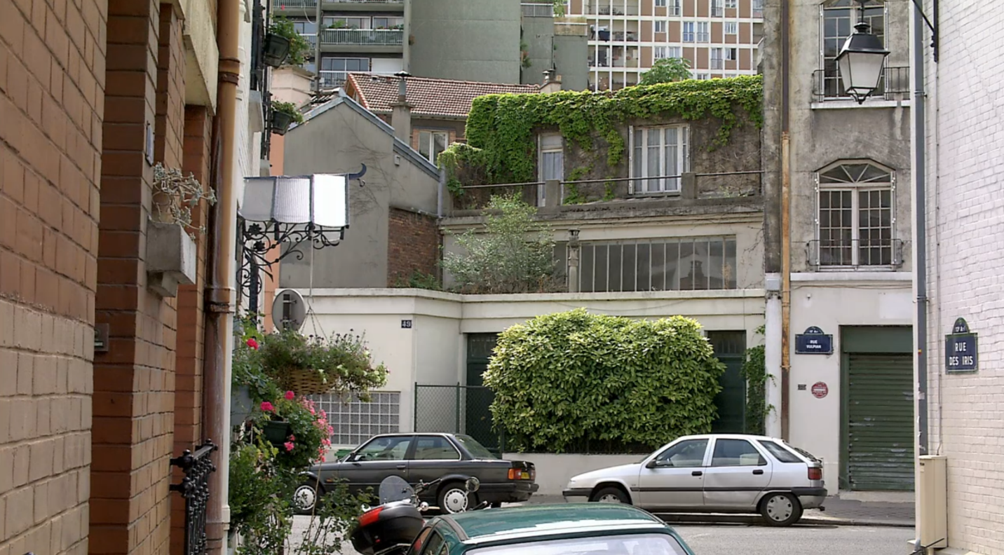
Scene 1: Establishing shot.
The first scene in Cache is an establishing shot of the Laurent family home. Credits roll as we look at a nearly static image of a street in Paris. As the audience, we are expecting a full immersion into the world of film, and there is a sense of comfort in the idea of being able to view all that there is, and all that there will be, within a specific cinematic realm. As we hear the seemingly non-diegetic voice talking over the credits, and as the tape is fast-forwarded by characters unknown, that illusion is shattered. The scene that we are watching is a recording of previous events, and we are the introduced to our protagonists, Georges and Anne Laurent, who are watching the tape in the film’s present time. What makes this scene even more striking is the introduction of an unknown point of view which reappears throughout the film, and follows Georges as he walks out to examine the street in which the recording took place. We are unaware from whose perspective we are viewing the protagonist. However, one thing is clear- the family is under surveillance. Both Pierrot and Georges receive disturbing childlike drawings, and videotapes become increasingly more specific, showing an anonymous person driving or walking to an unspecified location which will later gain meaning. Haneke uses surveillance in two distinctive ways in the film. It is used to form the narrative, namely inform the viewer of both the present and the past, thusly uncovering personal and global histories. It also represents an important cultural and political context in the film, one directly tied to the post 9/11 era.
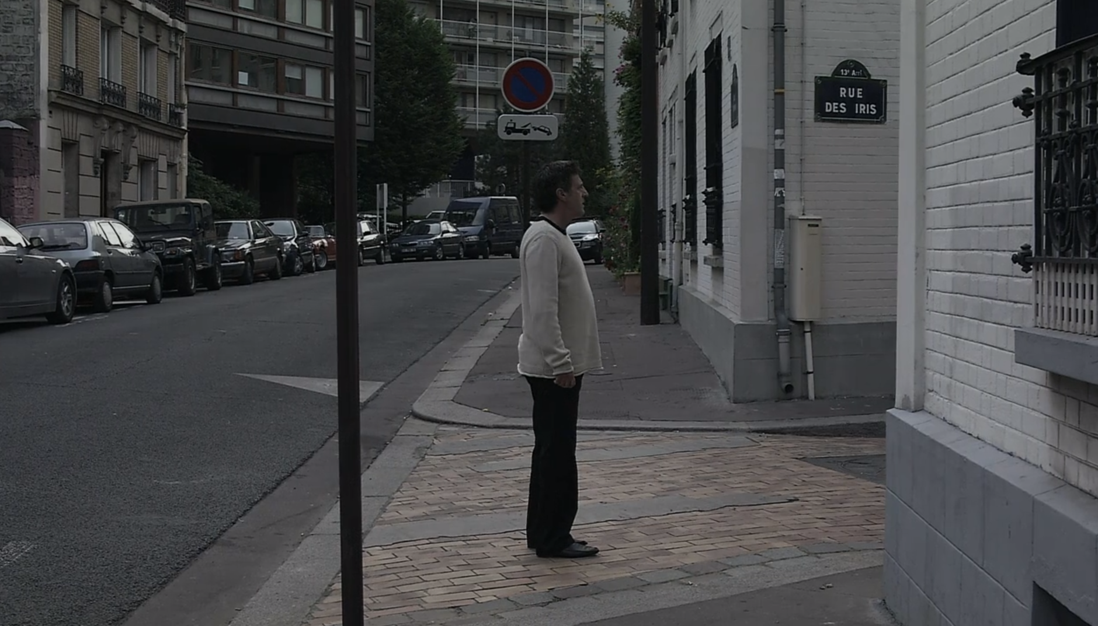
Scene 2: Unknown perspective.
As we are introduced to the deeply coveted event of Georges’ childhood through the anonymous videotapes, Haneke uses surveillance to uncover the personal history of the French protagonist. The tapes guide us to Georges’ family home, and ultimately to Majid’s apartment. What exactly does this mean for us as the audience? If the film was narrated through Georges’ perspective, as opposed to being guided by surveillance, would we have even been able to ‘‘uncover’’ Majid and his story? Not likely. In fact, Georges is adamant about keeping this history hidden from his wife and son. In an explosive fight, Anne is visibly distraught by Georges’ refusal to admit who he sees as the culprit. He does not offer an explanation for his behavior, nor any sort of remorse for keeping such a secret from his wife. During a visit to his mother, he inquires about Majid. She is as equally dismissive, stating that she does not remember the young Algerian boy. The ‘‘hush-don’t tell’’ perspective of Georges, and his family at large it seems, is disturbed by the appearance of individual clues in form of surveillance. Georges cannot help but retract back to his early childhood, as his sense of stability and safety is shaken, and as he ponders who is at fault for ‘‘terrorizing’’ of his family.
Ultimately, it does not really matter who is sending the tapes in the film. We never find out in any case, given Haneke’s refusal to answer any major questions in the film. ‘‘I'm not going to give anyone this answer. If you think it's Majid, Pierrot, Georges, the malevolent director, God himself, the human conscience – all these answers are correct. But if you come out wanting to know who sent the tapes, you didn't understand the film. To ask this question is to avoid asking the real question the film raises, which is more: how do we treat our conscience and our guilt and reconcile ourselves to living with our actions? People are only asking, "whodunnit?" because I chose to use the genre, the structure of a thriller, to address the issues of blame and conscience, and these methods of narrative usually demand an answer. But my film isn't a thriller and who am I to presume to give anyone an answer on how they should deal with their own guilty conscience?’’. While the majority of scholarship has really emphasized the whodunit narrative, the themes of guilt and collective memory are explored at great length in the film. In order to address these issues, we must look at how they are represented in Cache both visually and thematically.
The idea of collective memory was initially explored by French philosopher Maurice Halbwachs in The Collective Memory, where he explains that societies have collective memories that expand beyond individual experiences. One’s understanding of the past, he claimed, can be tied to group consciousness. Collective memory can be shared among a number of different groups, including nations, cultures, ethnicities, religious groups, generations etc. Frantz Fanon’s The Wretched of the Earth is a close look at the immense effects of colonization, examined partially through the lens of psychology and mental health. Fanon looks at nationalism as a unifying factor of formerly colonized peoples, as well as the role of colonialism in the formation of identities. In the book he writes: ‘‘On the unconscious plane, colonialism…did not seek to be considered by the native as a gentle, loving mother who protects her child from a hostile environment, but rather as a mother who unceasingly restrains her fundamentally perverse offspring from managing to commit suicide and from giving free reign to its evil instincts. The colonial mother protects her child from itself, from its ego, from its physiology, its biology, and its own unhappiness which is its essence.’’ In Cache, Majid commits a suicide by slashing his throat. The event is captured on camera by the unknown stalker. The French protagonist is haunted by the event at the end of the film, while still refusing to accept his role within a system of larger French society, one which has historically failed to acknowledge its guilt over colonial violence. An intersection of personal and global histories is at play here, as the trauma experienced by Majid is not an entirely individual experience, but one of an entire community of people. The guilt that Georges is failing to admit to, on the other hand, is embedded in his identity as a citizen of a former colonial power. In the film, Georges says: ‘‘I don’t know what dumb obsession he fed you. But I can tell you this. You’ll never give me a bad conscience about your father’s sad or wrecked life. I’m not to blame.’’
The Aftermath of 9/11, Politics, and Cache
‘’We also must never forget the most vivid events of recent history. On September the 11th, 2001, America felt its vulnerability – even to threats that gather on the other side of the earth. We resolved then, and we are resolved today, to confront every threat, from any source, that could bring sudden terror and suffering to America.’’ - George W. Bush, 2002.
The September 11 attacks forever changed the American society and completely transformed its foreign policy. The aftermath was marked by a major spike in anti-Islamic sentiments. Islamophobia became widespread, and international travel was suddenly a hotspot for racial profiling. This is also an era of aggressive American foreign policy, marked by preemptive military invasions, as initiated by the Bush administration. Cache captures the post 9/11 tension through the use of media, specifically the channel EuroNews that playing in background while the main characters are preoccupied with other matters, mainly Pierrot’s disappearance. In any case, the wealthy Georges and Anne film do not need to be informed on global matters like the Iraqi War or the Israeli-Palestinian conflict, as international politics do not play a large role in their lives. The kind of passive behavior they exhibit towards the word outside of comfortable, Western European life can also be examined through Georges’ relationship with Majid. While Georges has seemingly moved on from the events of his childhood, and was able to carve out a successful career and make a comfortable life for himself, Majid’s life was forever changed by the past, and he is not awarded the luxury of being passive or apolitical.
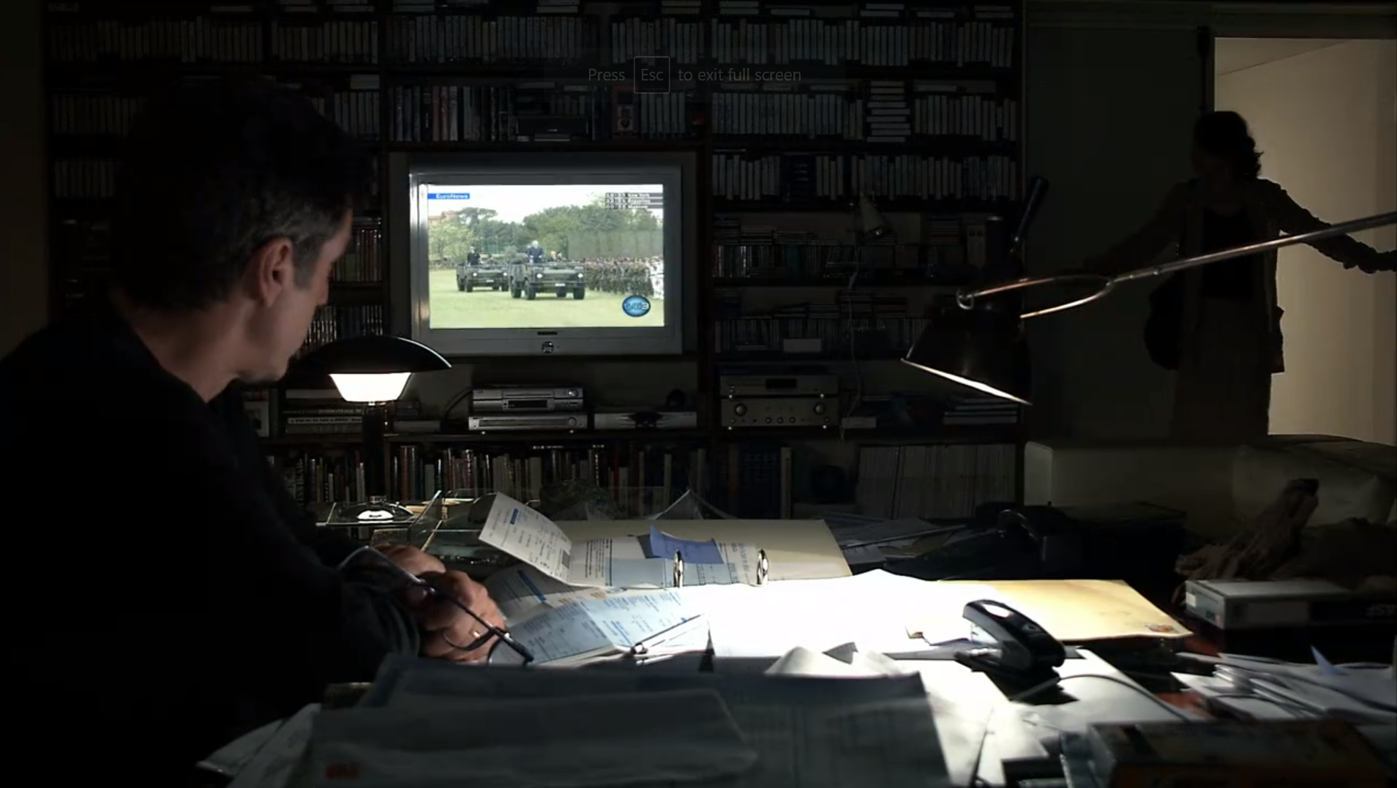
Scene 3: The role of traditional media.
Submission, a novel written by the controversial French writer Michel Houellebecq, imagines a scenario in which an Islamist takeover of France occurs after a majority Muslim party wins the election. Just like Georges, the main character of the book, Francois, only starts taking a keen interest in politics once his own life is directly impacted by the changing political climate in France. Francois’ decision to learn more about French history is largely due to the rumored and impending changes in the education system, which he happens to be a part of. Minority groups, which are assigned one dimension qualities, cannot not help but be involved in politics, as their identities are inherently political. It is also interesting that as the narrator is the one informing the readers about the imagined restructuring of the French nation, when he himself knows nothing about how these changes are implemented. This is quite similar to how Georges reacts when confronted about his role in the downturn of Majid’s life. His ignorance and complacency is intersected with the idea of white paranoia is also at play in Cache, seen in the scene where Georges confronts a black cyclist. The film here tackles the modern impacts of colonialism, as well as the racial dynamics in current France.
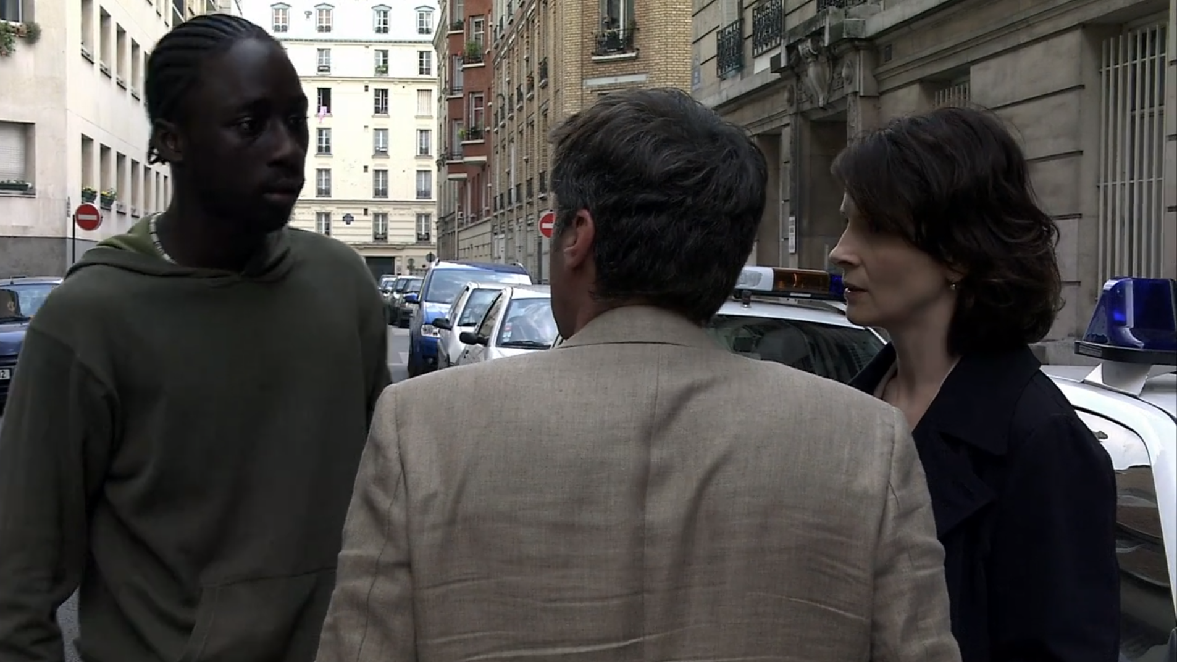
Scene 4: Georges and the cyclist.
The Gaze, Transnational Cinema
‘‘This film was made in France, but I could have shot it with very few adjustments within an Austrian – or I'm sure an American – context.’’-Michael Haneke
Transitional cinema is a broad and evolving concept within the field of film studies that generally engages with the everchanging influences of globalization. Usually when a film is referred to as ‘‘transnational’’, one is most likely referring to its abilities to cross cultural boundaries, and resonate with a much wider audience. While Haneke seems to be arguing that Cache’s story is not bound by any particular national boundaries, his positioning as an Austrian director, and more broadly a European filmmaker, remains significant to the film’s gaze. Cache certainly looks at the matter through a critical lens. However, it seems like Haneke is also referencing his own experiences with collective memory and guilt. Austria has been referred to as the ‘‘black sheep of Europe’’ for not properly acknowledging its fascist past. Austrian historian Gunter Bischof writes: ‘‘Has Austria mastered the horrid chapters of its World War II past? For some 40 years, Austrians hid behind the official "victim's doctrine." This argument that Austria was a victim of Hitler Germany broke apart after the 1986 "Waldheim affair." A more candid confrontation with its past became the hallmark of Austrian politics in the 1990s, as Austrians' contribution to Nazi war crimes were no longer glossed over. In 2000-01 the Schüssel government agreed to two major restitution settlements with victims of forced labor and Nazi "aryanization." The Historikerkommission began publishing reports on wartime property transfers and postwar restitution efforts in 2003. In terms of World War II memory Austria is no longer "the black sheep" of Europe.’’ Michael Haneke happens to belong to the new wave of filmmakers that actively engage with Europe’s past critically, and often through a distinctly post-colonial lens.
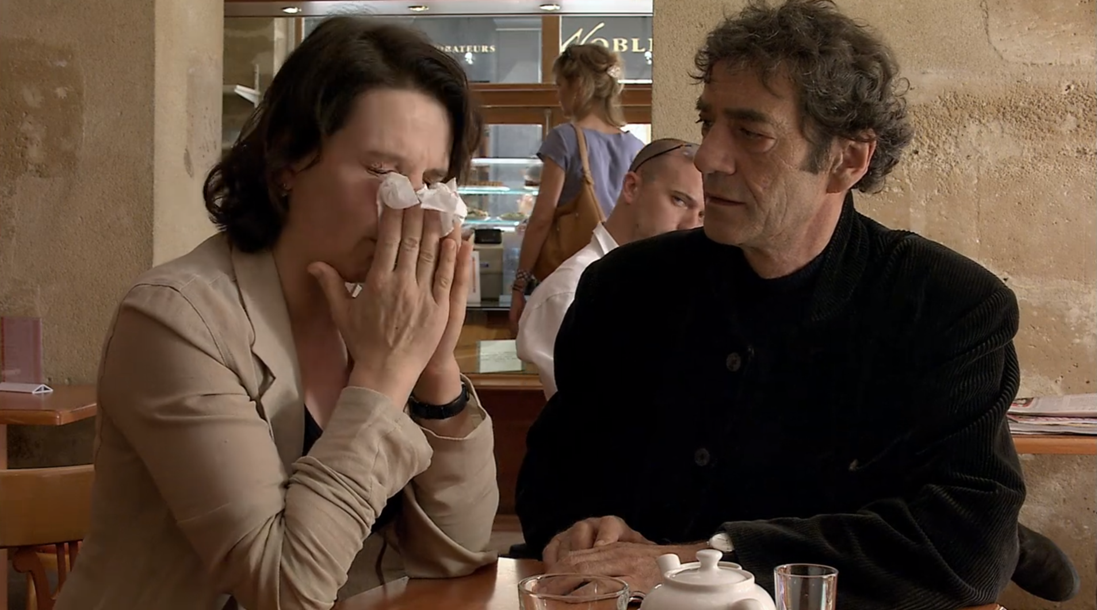
Scene 5: Mysterious man.
Apart from Haneke’s positioning as an Austrian filmmaker, many have argued that the use of surveillance in Cache represents a gaze in itself. An instance that particularly stands out in the film is when Anne and Pierre are sitting at a café, and a mysterious man is shown to be looking at them. The scene is quite haunting, and the mysterious character plays no other role in the film. The idea of not just unwanted, but constant and unperceived surveillance, seems to be another theme in Cache. In Looking for the Gaze, Todd McGowan argues: ‘‘In Lacan's later work, the gaze becomes something that the subject encounters in the object; it becomes an objective, rather thana subjective, gaze. As he put it in Seminar XI, "The object a in the field of the visible is the gaze." The gaze is not the look of the subject at the object, but the point at which the object looks back. The gaze thus involves the spectator in the image, disrupting her/his ability to remain all-perceiving and unperceived in the cinema.’’ McGowan is specifically discussing the Lacanian film theory and the gaze’s role in changing our filmic experiences. He mentions that films that deviate from the ‘‘the safe distance’’ and an ‘‘assumed mastery’’, are having their audiences encounter the ‘‘real’’. Cache seems to be doing exactly that, disrupting a kind of normalized relationship between those who are being watched, and those who engage in the watching.

Conclusion
‘’There is just as much evil in all of us as there is good. We're all continuously guilty, even if we're not doing it intentionally to be evil. Here we are sitting in luxury hotels, living it up on the backs of others in the third world. We all have a guilty conscience, but we do very little about it.’’- Michael Haneke.
Cache does not merely examine the idea of what it means look at someone, yet delves into the notion of what it means to be looked at. Videotapes and drawings are not the only forms of surveillance present in the film. It is everywhere, making it increasingly hard for the main protagonist to move on from a deeply traumatic childhood event. What he fails to see is that his complacency within a much larger framework of colonialism and guilt (or lack thereof), and the notion of personal responsibility without concern for existing structures of oppression (such as the police), are remnants of the same system that killed Majid’s parents. While Georges did not explicitly take part in colonial violence, his refusal to accept his guilt is more than brutal, and undermines the immense social and political disparities between him and his long lost adopted brother. As the audience, we are ‘‘in’’ on his game because to the use of surveillance in the film. However, do we actually learn anything about Georges at the end of the film? Is he that complicit? That remains unclear. What seems to matter a lot more in Haneke film’s is not Georges, nor Anne, nor even Majid and his son, yet the idea of uncovering histories that have been buried for so long, and doing it in an incredibly critical and radical way.

References
Bischof, Günter. “Victims? Perpetrators? ‘Punching Bags’ of European Historical Memory? The Austrians and Their World War II Legacies.” German Studies Review, vol. 27, no. 1, 2004, pp. 17–32. JSTOR.
Bourdieu, Pierre. Algeria 1960: The Disenchantment of the World: The Sense of Honor: the Kabyle House or the World Reversed: Essays. Cambridge [England: Cambridge University Press, 1979. Print.
Celik, Ipek A. “‘I Wanted You to Be Present’: Guilt and the History of Violence in Michael Haneke's Caché.” Cinema Journal, vol. 50, no. 1, 2010, pp. 59–80. JSTOR.
Fanon, Frantz, and Charles L. Markmann. Black Skin, White Masks., 1967. Print.
Fanon, Frantz. The Wretched of the Earth. New York: Grove Press, 1963. Print.
Foucault, Michel, 1926-1984. Discipline and Punish: The Birth of the Prison. New York: Pantheon Books, 1977.
Friedmann, Georges, and John H. Mueller. “Maurice Halbwachs, 1877-1945.” American Journal of Sociology, vol. 51, no. 6, 1946, pp. 509–517. JSTOR.
Geiger, Jeffrey, and R L. Rutsky. Film Analysis: A Norton Reader. New York: W.W. Norton, 2005. Print.
Herzog, Todd. “The Banality of Surveillance: Michael Haneke's ‘Caché’ and Life after the End of Privacy.” Modern Austrian Literature, vol. 43, no. 2, 2010, pp. 25–40. JSTOR.
Halbwachs, Maurice, 1877-1945. The Collective Memory. New York :Harper & Row, 1980.
Houellebecq, Michel, and Lorin Stein. Submission., 2015. Print.
Kelly, Michael. “Essay Review: Fast Cars, Clean Bodies: Kristin Ross. Fast Cars, Clean Bodies: Decolonization and the Reordering of French Culture (London and Cambridge, MA: The MIT Press, 1995).” French Cultural Studies, vol. 6, no. 18, Oct. 1995, pp. 413–418.
Lie, Sulgi, and Daniel Fairfax. Towards a Political Aesthetics of Cinema: The Outside of Film. Amsterdam University Press, 2020. JSTOR, www.jstor.org/stable/j.ctv15d7zzk. Accessed 8 Dec. 2020.
McGowan, Todd. “Looking for the Gaze: Lacanian Film Theory and Its Vicissitudes.” Cinema Journal, vol. 42, no. 3, 2003, pp. 27–47. JSTOR.
Porton, Richard, and Michael Haneke. “Collective Guilt and Individual Responsibility: An Interview with Michael Haneke.” Cinéaste, vol. 31, no. 1, 2005, pp. 50–51. JSTOR.
Said, Edward W. Orientalism. New York: Pantheon Books, 1978. Print.
Wallas, Graham. “Jeremy Bentham.” Political Science Quarterly, vol. 38, no. 1, 1923, pp. 45–56. JSTOR.
Wheatley, Catherine. Michael Haneke's Cinema: The Ethic of the Image. New York and Oxford: Berghahn Books. 2009.
Yacine, Tassadit, et al. “Pierre Bourdieu in Algeria at War: Notes on the Birth of an Engaged Ethnosociology.” Ethnography, vol. 5, no. 4, 2004, pp. 487–510. JSTOR.

